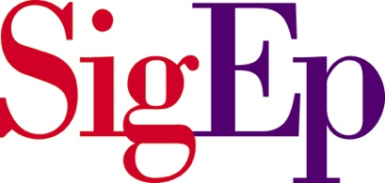
RECRUITMENT STANDARDS TEMPLATE
Recruitment standards are the most effective way to ensure that the chapter maintains high expectations for membership through changes in leadership and chapter membership. Standards bring consistency. The template below provides six areas of recruitment standards, with sample standards in each category that can be tailored. Blank spaces are provided for additional standards to be added.
To be eligible to receive an invitation to join Sigma Phi Epsilon, a potential new member must meet all of the required standards (highlighted in red) and must have at least one standard met from each of the six areas listed.
Sound Mind | 3.0 GPA
Sound Body | Played a sport (varsity, club, high school)
 | Has a fitness routine or diet
 | Doesn’t abuse alcohol or drugs
Involvement | Community Service Involvement
 | Student Organizations/Clubs
Soft Skills | Handshake/Eye Contact
 | Good Conversation
 | Body Language
Work Ethic/Passion | Scholarships
 | Honors
 | Awards
Values | Lives with VDBL
 | He wants SigEp’s experience (BMP)

